Hello,

Here I will **represent screenshots of my work** with profiler(dotTrace 10.0.2).

This is the initial report of “*Solar System*” solution:

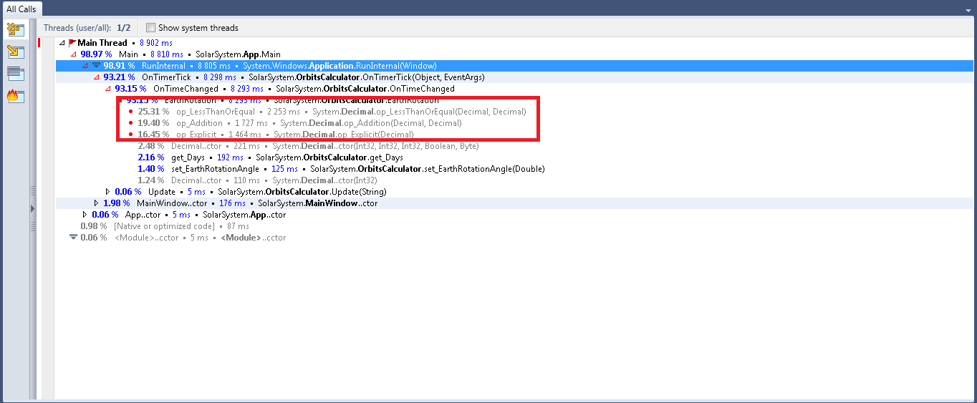

I found that in *OrbitCalculator* class there is a private method “**EarthRotation()”** where variable “**step**” (which is in for-loop) was **casted when that was not needed**. The step itself was incremented by number that was in double number type’s range.

After that the next report showed remarkable advance in performace:

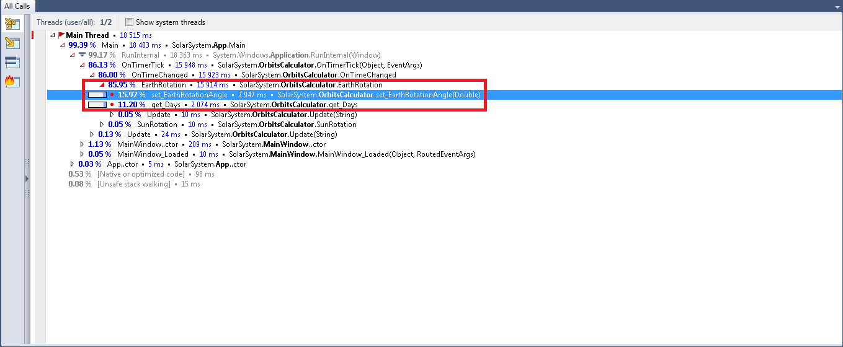

But still some **other optimizations are yet to be made**. As you can see from the report there are multiple calls on these variable methods: the *setter* of “**EarthRotationAngle**” and *getter* of “**Days**”. These two variables are used mostly in the for-loop in which the unnecessary cast was made. So I decided to remove the for-loop. Yes, it is not smart decision to be made but from performance point of view the **program was much faster**: ---> continues on next page

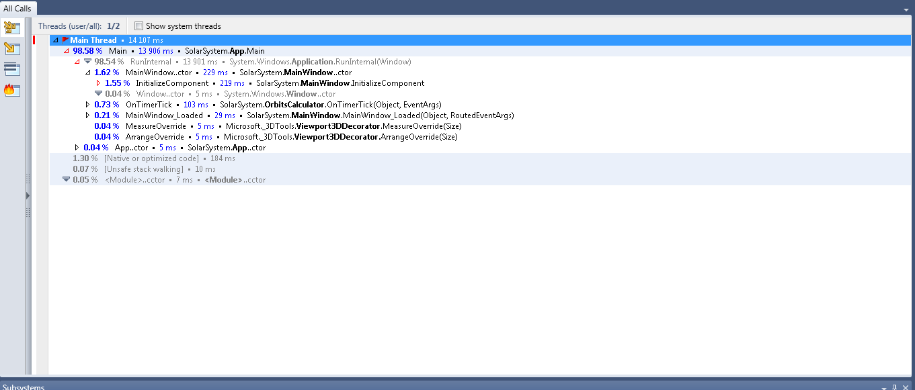

Description for the rest of the programs can be found at”HomeworkInfo.txt”.